Promega Technology——

miRNA/siRNA靶标研究工具

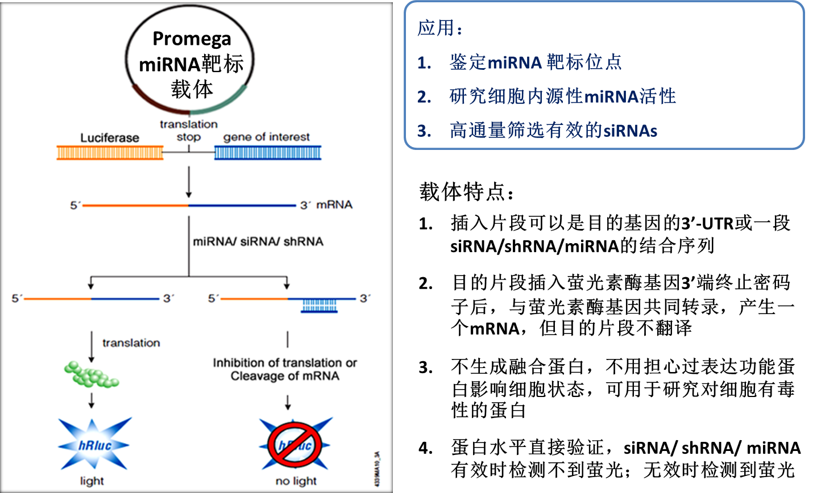

萤光素酶报告基因：

* **检测蛋白：**miRNA与靶标mRNA结合后，mRNA可能不被降解，但蛋白翻译受抑制，用PCR法检测mRNA无变化，但萤光素酶报告基因检测萤光素酶蛋白的产生，更加准确反映miRNA作用机制
* **细胞无内源性萤光素酶活性：**无细胞内源性酶活性干扰
* **灵敏：**最低检测至10-20 mole or ~6000 个萤光素酶分子
* **线性范围宽：**108 个数量级
* **操作简便：**5分钟完成细胞裂解、样品制备和检测，同一样品中可检测萤火虫和海肾萤光素酶双报告基因
* **结果量化：**化学发光法检测，发光仪读数直接得到量化结果

双报告基因载体：

|  |  |  |  |  |  |  |  |
| --- | --- | --- | --- | --- | --- | --- | --- |
| **Cat.#** | **载体** | **骨架** | **靶标报告基因** | | **内参报告基因** | | **转染方式** |
| **萤光素酶** | **启动子** | **萤光素酶** | **启动子** |
| **C8021** | **psiCHECK-2** | pGL3 | hRluc (海肾) | SV40 | hluc+ (萤火虫) | TK | 瞬时转染 |
| **E1330** | **pmirGLO** | pGL4 | Luc2 (萤火虫) | PGK | hRluc (海肾) | SV40 | 瞬时转染或稳定转染 |

单报告基因载体：（需共转染萤火虫萤光素酶载体E1741或E6681做内参）

|  |  |  |  |  |
| --- | --- | --- | --- | --- |
| **Cat.#** | **载体** | **靶标报告基因** | **启动子** | **转染方式** |
| **C8011** | **psiCHECK-1** | hRluc (海肾萤光素酶) | SV40 | 瞬时转染 |

**研究思路 一：（明确miRNA结合位点，研究细胞内源性miRNA活性）**

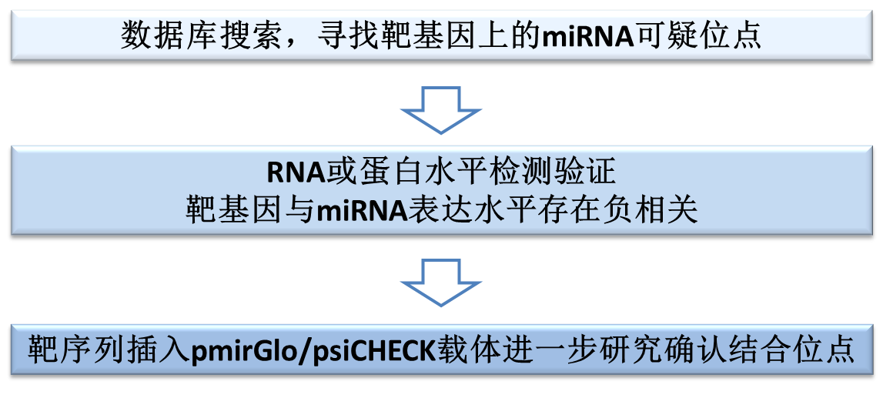

**miRNA研究举例 一**

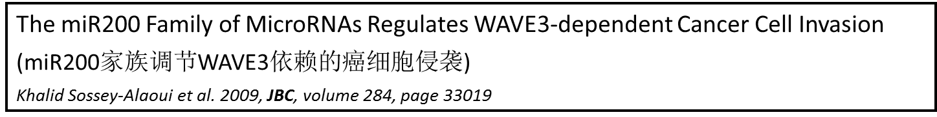

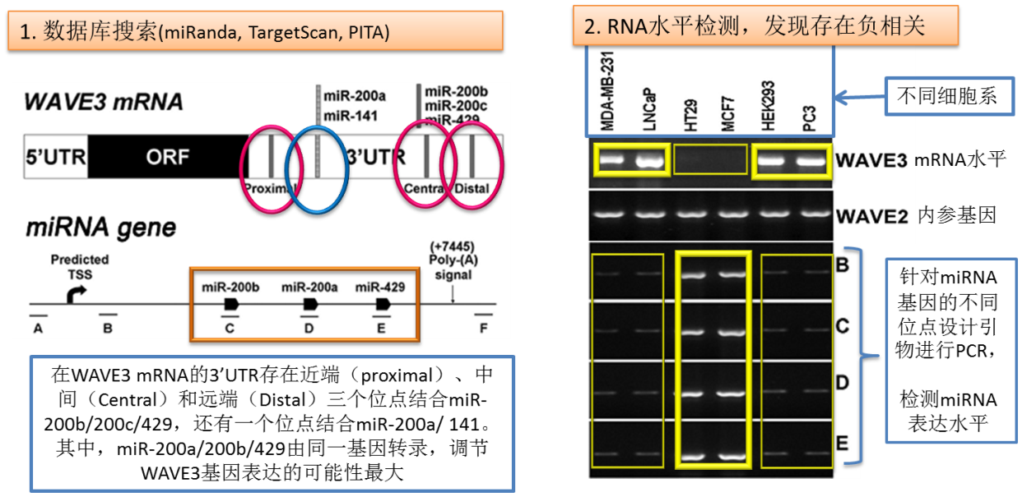

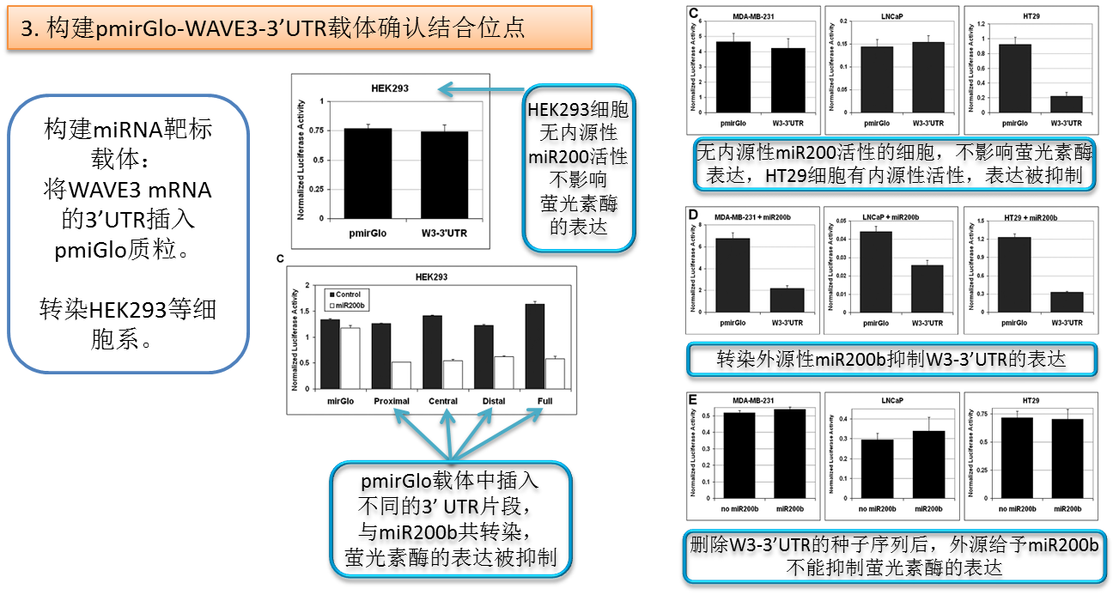

**miRNA研究举例 二**

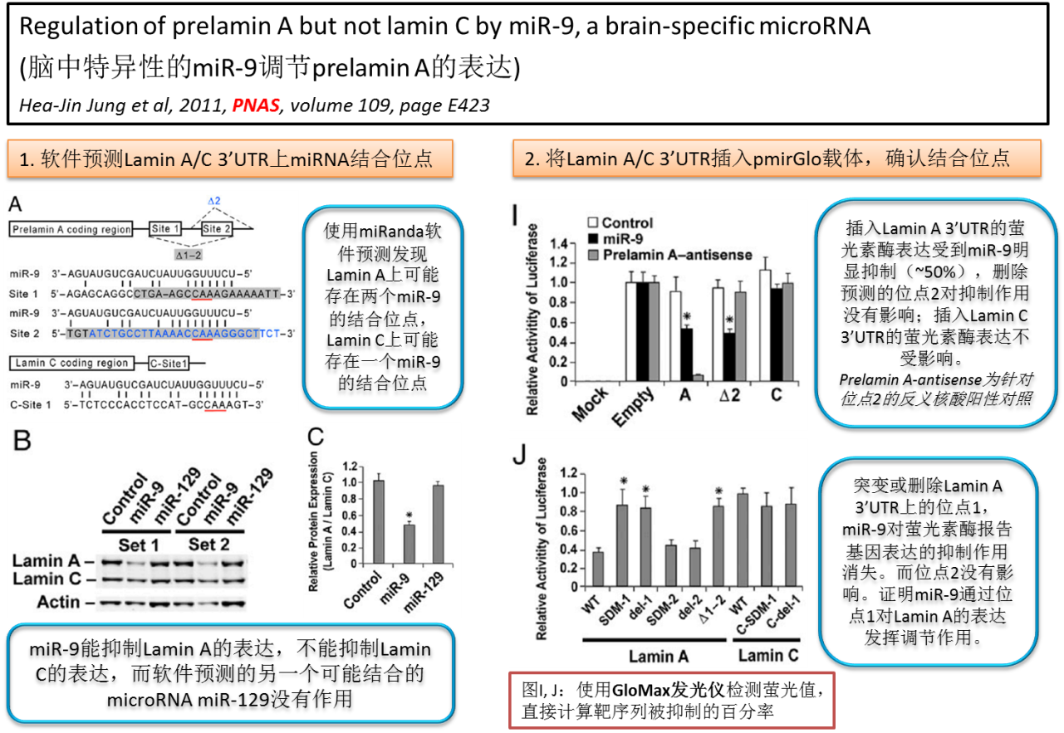

**miRNA研究举例 三**

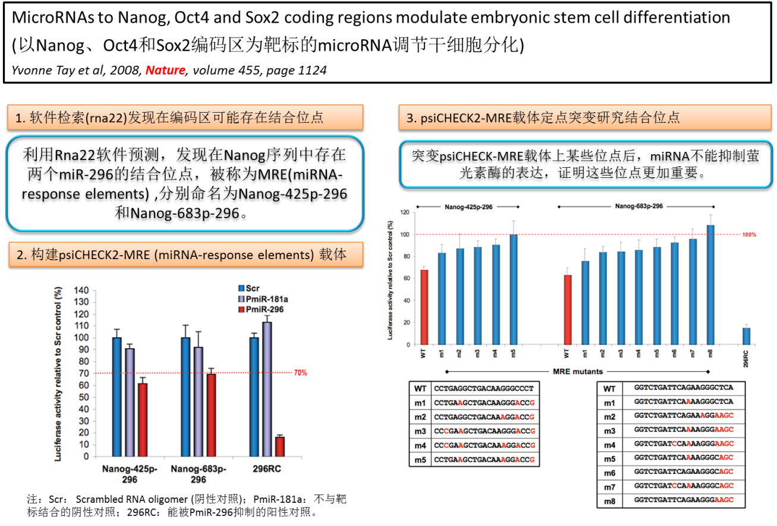

**研究思路 二:（高通量筛选有效的siRNA）**

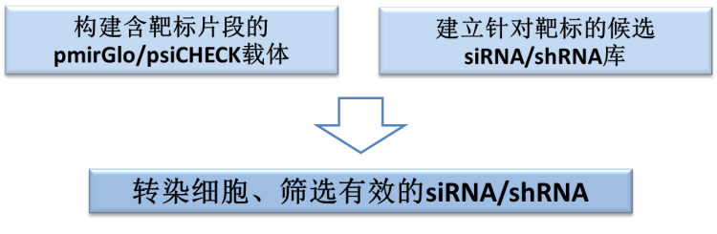

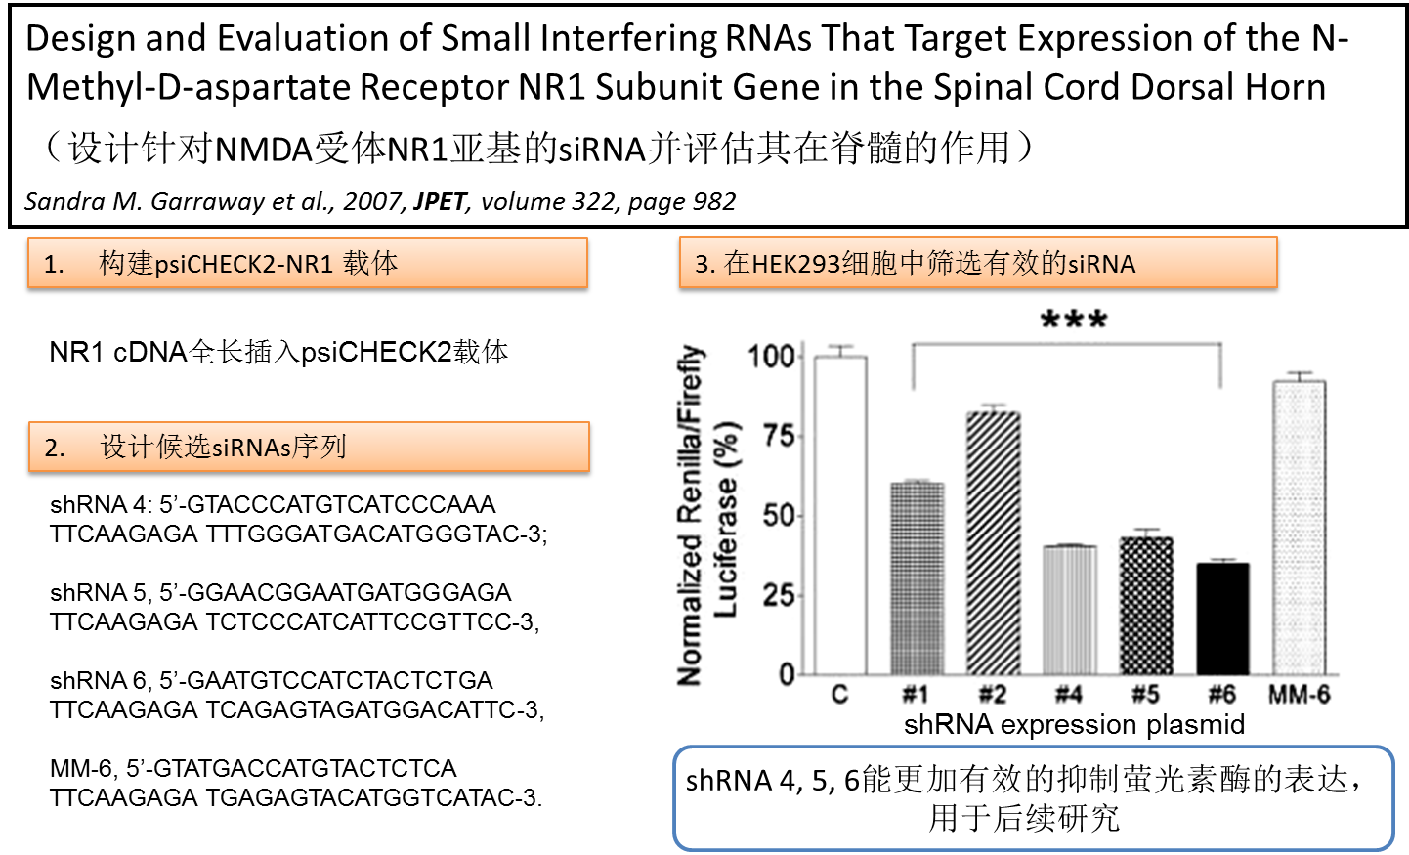

miRNA研究文献（更多研究文献可用psiCHECK或pmirGlo为关键词在Highware检索得到）：

1. BRCA1 regulates microRNA biogenesis via the DROSHA microprocessor complex. *Shinji Kawai et al, 2012,* ***J. Cell Biol*** *volume 197: 201*
2. Sperm-borne microRNA-34c is required for the first cleavage division in mouse. *Wei-Min Liu et al., 2012,* ***PNAS****, volume 109: 490*

siRNA/dsRNA应用文献：

1. Loss of human Greatwall results in G2 arrest and multiple mitotic defects due to deregulation of the cyclin B-Cdc2/PP2A balance. *Andrew Burgess, et al., 2010, PNAS, 107, 12564–12569*
2. The SoxC protein SEM-2 opposes differentiation factors to promote a proliferative blast cell fate in the postembryonic mesoderm. *Chenxi Tian, et al., 2011, Development 138, 1033-1043*

shRNA应用文献：

1. RIAM Regulates the Cytoskeletal Distribution and Activation of PLC-1 in T Cells. *Nikolaos Patsoukis et al, 2009,* ***Sci. Signal****., volume 2: ra79*
2. AS160 Modulates Aldosterone-stimulated Epithelial Sodium Channel Forward Trafficking. *Xiubin Liang et al, 2010,* ***Mol. Biol. Cell****., volume 21: 2024*

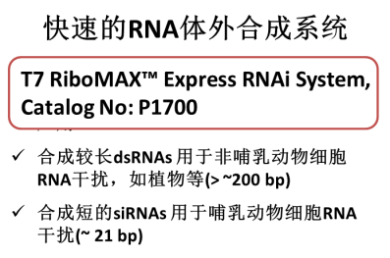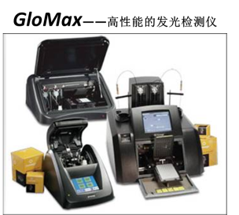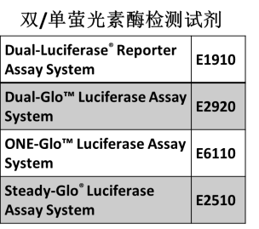相关产品：